School Growth Plan

School Overview

Babine Elementary Secondary School is a remote K-12 school in Granisle B.C. We are a small and highly personalized school. We have 41 students, 22 of whom travel on the bus from Tachet. We have 31 students (76%) who claim Aboriginal ancestry. We have 15 students (37 %) with current learning designations. Our staff is made up of a teaching principal, one classroom teacher, one Language and Culture teacher, 2 and a half learning support workers, one Indigenous advocate, a meal prep worker, and an office administrator. The staff is working diligently to create a safe learning environment where students feel like they belong and can become passionate learners.

Please note that due to our small size it is difficult to appropriately mask our data and maintain student confidentiality. As a result, this document will mainly focus on some overarching themes and anonymous individual stories.

School Plan – A Living Document

To ensure that this plan is accurate and relevant to our learning community the following groups have participated in the creation of this school growth plan:
- Teaching staff and support staff
- PAC members
- A student group
- District staff members

This document will be evaluated and updated at regular term intervals, and we will add information as we go during the year. This allows us to ensure that this plan is reflective of the current needs of the learners at BESS.

District Goal: Create Student Success

Section 1: Literacy:

- Data: We have completed several formal and informal assessments on literacy this year, including PM Benchmarks (K-GR 4 reading level), the FSA, our district reading assessment, and teacher observations. Our data demonstrates that the vast majority of our students are reading below grade level. Our PM benchmark data shows very few students in grades 1-6 are reading at grade level. Our data along with teacher observation show that our students are struggling with decoding texts and accessing phonics skills. This has been a trend throughout the past few years that we are looking to address.

School Goal
Our main goal at BESS is that all students improve their current reading scores by 1 grade level, as measured by PM Benchmarks and other assessments and teacher observations. In doing so, students will begin to demonstrate grade-level fluency and comprehension skills. To accomplish this, we are emphasizing fluency skills, sight word recognition, and key-decoding skills.

Actions
In order to meet this goal we have initialized several actions:
- We have school-wide reading twice a day. Students are reading ‘Just Right’ levelled texts daily. This is supporting their fluency and many have started to make progress.
- Teachers conference with at-risk students during our reading sessions.
- BUDDY reading has been initialized to develop confidence and a love of reading. This has been a positive program between the primary and senior students.
- A sequential phonics intervention is commonly provided to students in need by LSW staff, as well as whole-class instruction in the K-3 class.
- Sight word practice is provided for several students.
- Reading A-Z pilot program has been initialized. This digital program provides gamified learning and digital assessment materials to teachers.
- Through our grant with Indigo, we have received new books and frequently order books that students request. This has helped engage many students in reading times.
- When students’ fluency has improved we will be using the district literacy assessment to focus on comprehension skills.
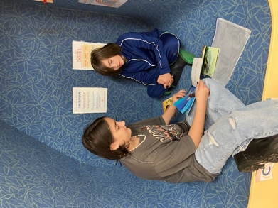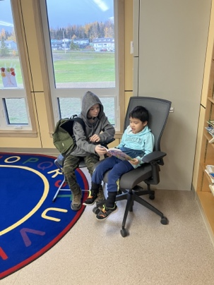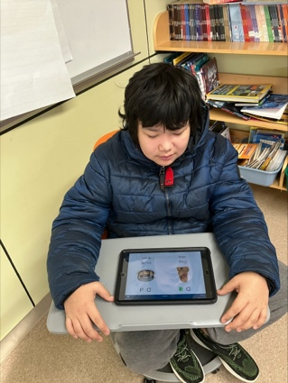
Literacy at BESS

June 2024 Reflection:

It is difficult to fully encompass the progress that students have made in literacy this year. Many students’ PM benchmark levels have increased throughout the year, with some students even growing 10+ levels. However, most our students still remain below grade level in terms of their fluency and compression. This term the grades 4-7 also took an assessment called the CCR. This was one of our first attempts at using these assessments with this age group. Not enough students were able to complete the assessment to share results, however we are hopeful that during the fall semester we will have more success. The past few months we were able to secure extra staffing time to have reading groups for students reading below grade level. These groups were supportive and something we are hoping to expand upon in the fall.

November 2024 Reflection

During the start of the year we have conducted a number of literacy assessments including another round of PM Benchmarks for the elementary students and the Cross Curricular Reading assessment with the grades 7-12 students. At a glance, our PM data demonstrates the majority of students remain below grade level in terms of their fluency. However, at an individual level we are seeing that most students have been making steady progress and our becoming more independent readers. We have started to log PM updates on tracking forms that will be sent home each term. Many students have demonstrated steady progress in terms of fluency. This year, our new teacher has introduced a phonics program called ‘Words Their Way’ which has been implemented throughout the elementary classrooms. Our CCR results and teacher observation have shown that the majority (75%) of high school students have strong fluency however, their comprehension skills are further behind. Specifically, the group struggles with identifying the main ideas and supporting details in texts. Our goal remains that each student will develop their reading skills by 1 grade level. However, we will be focusing specifically on fluency levels with elementary students and comprehension skills with high school students.

Student Story: Student A has been working hard to address their reading skills over the past year. With daily adult support, they have worked through various phonics tools and sight word practice to improve their fluency level. They have also started to read daily just right reading books. As a result, their fluency has grown several grade levels, and they are a much stronger reader.

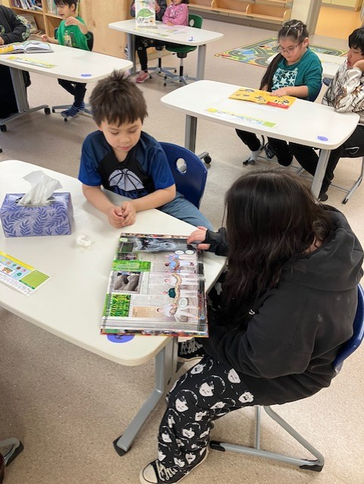

Buddy Reading

May 2025 Reflection

BESS has had a wonderfully successful year in terms of literacy. Although the majority of our students are still several grade levels below, we are starting to see more growth. This year we have started to chart student progress based on their PM reading levels. These charts are sent home with term report cards and document the students’ scores over time. The graph below demonstrates the overall progress that we have noticed in our grade 1-9 students who are still working on the PM scale. It demonstrates that 50 % of students grew at least 1-3 reading levels, while 44% grew more than 3 levels and the remaining 6 % stayed at their same level. Several students grew the equivalent of a full grade level throughout the year.

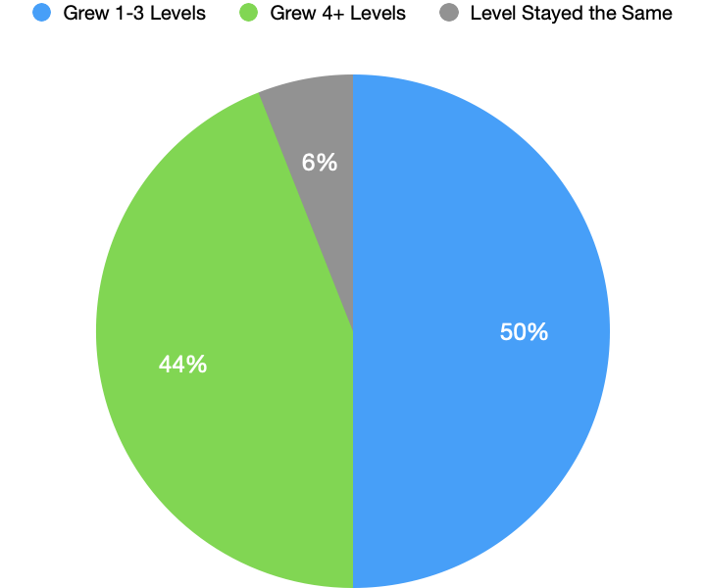

BESS PM Reading Progress Grade 1-9 Students

Many of the students in grades 7-9 have already passed reading level 30, the top of the PM scale and are working on comprehension skills. The senior class completed two reading assessments this year in the fall and the spring. Although it is difficult to display specific data points due to anonymity, we saw improvements in almost all senior students who completed both assessments. As a class their ability to identify main ideas and supporting details improved greatly.

November 2025 Update

Literacy has been a major focus for BESS so far this year. At the moment, many students in the K-7 classroom are still reading below grade level and have shown low fluency. In August and October 4 staff members attended a professional learning opportunity to engage in a phonics program called “Structured Literacy”. This is a systematic program which leads learners through new letters and sounds as well as common sight words which do not follow spelling rules. Other schools have already found success implementing the program 3 times weekly, and it will be implemented daily in the K-7 classroom. Our goal remains for each student to achieve grade-level fluency and comprehension.

The senior class has been engaging with online courses through EBUS. This has allowed the students to each participate in a grade-level course to support their writing, reading, and oral language skills. We have also purchased 20 new laptops which the students have used to greatly improve their writing. Many students are using the accessible technology like speech-to-text, text-to-speech, and spellcheck to increase their writing output.

Section 2: Numeracy
Data:

Data was collected on students in grades 4-6 and grade 9 on our District Numeracy Assessment. The data shows that the majority of students were not yet meeting or minimally meeting grade-level expectations. Most students across grades 3-12 are not yet familiar with grade level math concepts. Our understanding of students’ abilities in math has been further supported by FSA results and classroom observations.

Goal

Our goal for students is that each student will improve their understanding of numbers and operations and will be able to apply math concepts to their own lives and communities. We are aiming for each student to develop by one grade level by the end of the year, as measured by the district SNAP assessment. In order to accomplish this, we are emphasizing modelling skills and hands-on learning opportunities.

Actions

- We have continued the use of new manipulatives (blocks, fraction tiles, etc) that were purchased last year. Students have universal access to manipulatives to help explore and have worked hard on using these tools appropriately.
- We have embraced multi-modal solutions, where students are taught several ways to solve problems.
- We are regularly incorporating SNAP math strategies in classroom instruction to develop greater number sense.
- Programs such as Mathletics have been introduced to allow students to practice their operations with gamified activities.
- We are utilizing more hands-on learning opportunities, such as building, baking, making change during lunch, and games like “Multiplication Snowballs”. Grade 7-12 students have taken on self-selected passion projects. Many of which connect closely with math.

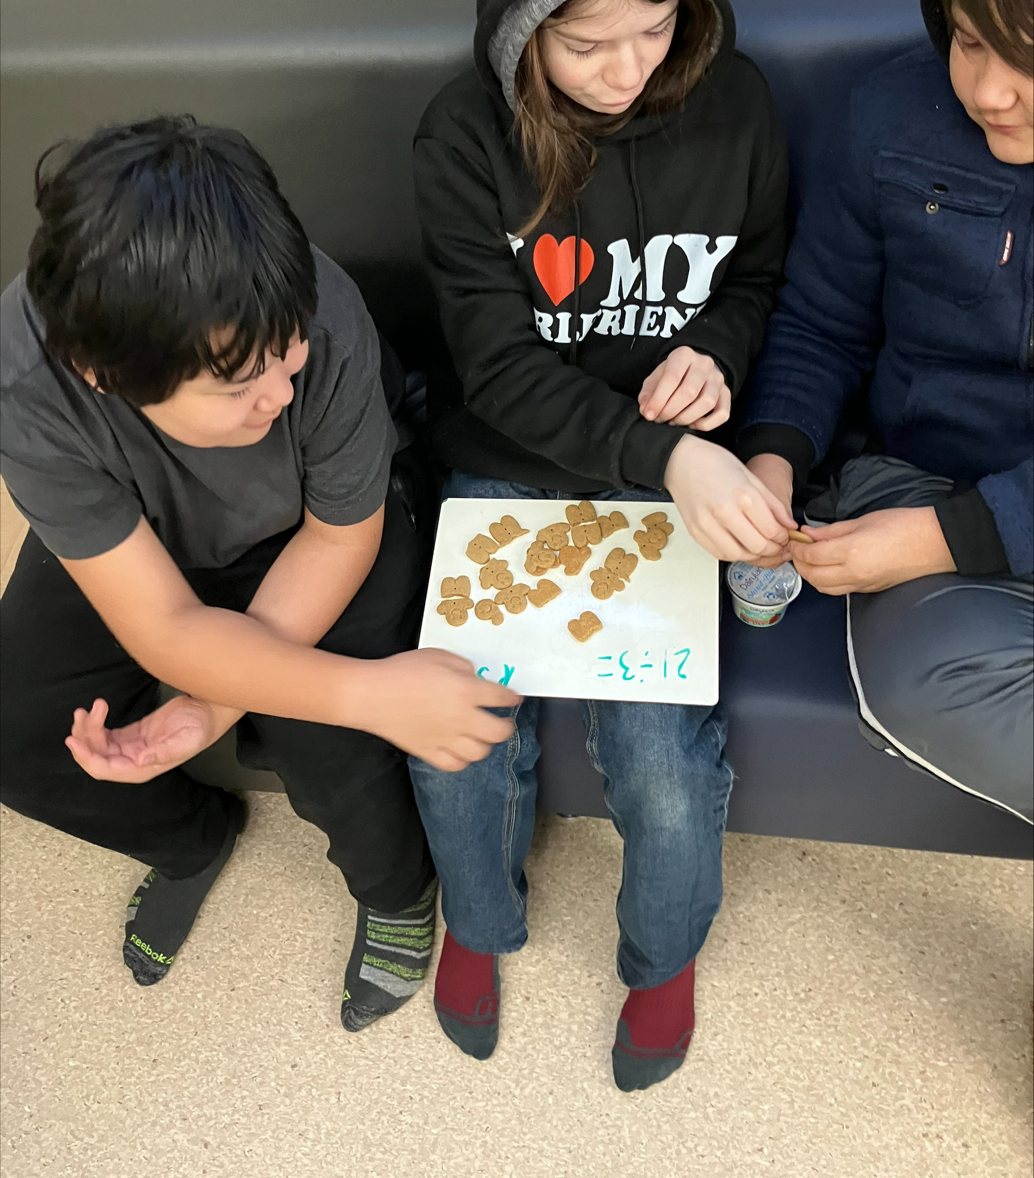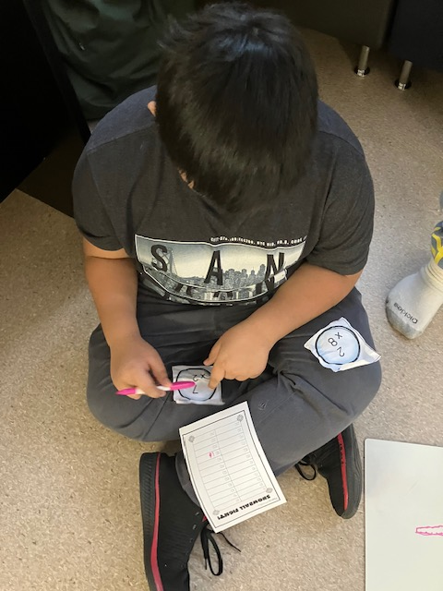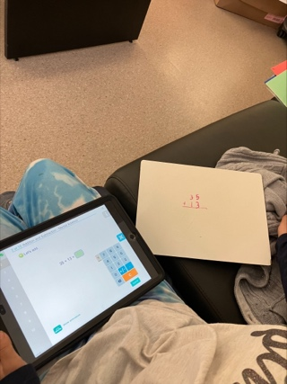

Math at BESS

June 2024 Update:

This has been a very successful year for math at BESS. Students have enjoyed hands-on learning opportunities and have improved their overall number sense. This spring all students from grade 1-9 completed a SNAP math assessment. We saw improvements across the majority of students, though it should be noted that the majority of students are still working below grade level. Students have become much more confident at accessing the resources they need to be successful (hundreds chart, manipulatives, etc). We are excited about what next year will bring for our math journey.

November 2024 Update:

This fall we completed SNAP math assessments for students from grades 3-11. The results demonstrated that the majority of students are not yet familiar with grade-level math concepts. This has made it difficult for them to apply these ideas to real-world situations. We have continued with our emphasis on hands-on math opportunities and exploring manipulative use in class. Experiential opportunities have included examples like the junior class organizing a holiday sale and the senior class studying our local spawning grounds and graphing the results. We have also focused on introducing more grade-level concepts with significant supports (calculators, 1-1 coaching, etc). For example, students in high school have started to complete coursework taken from the EBUS course catalogue. We have seen growth in most students, and they are starting to progress through their coursework.

Student Story: Student B was afraid they would not pass their high school math courses. The staff worked with them daily and provided extra support. Their confidence with math has grown tremendously and they have started to work through grade level concepts. They also went on to score ‘developing’ marks on their grade 10 assessments, demonstrating a progressing understanding of concepts.

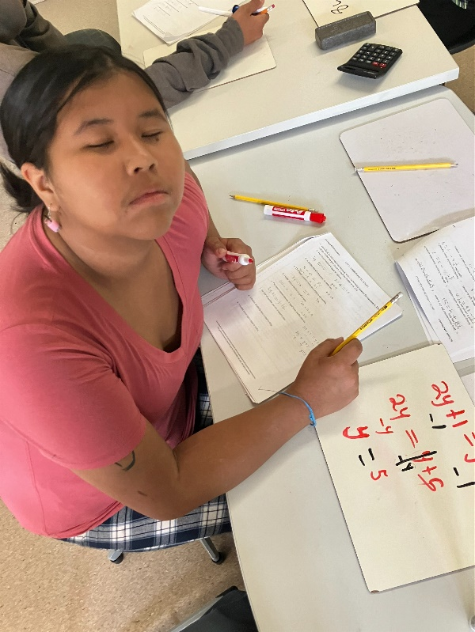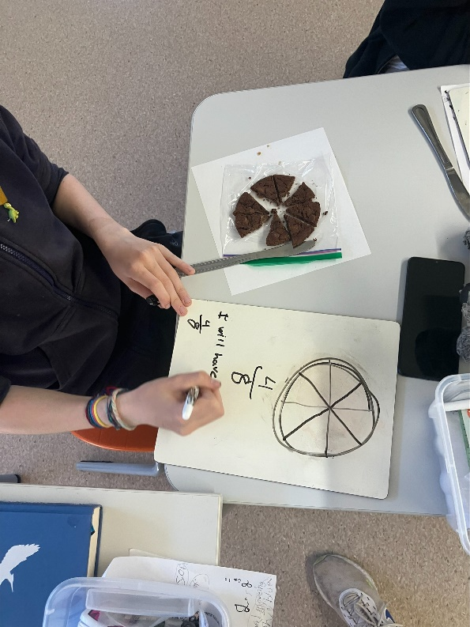

Hands-on math and working with new concepts.

May 2025 Update:

This spring we completed another session of the SNAP assessments, this time with students from K-11. These assessment results demonstrated the progress that students have made throughout the year. The vast majority of the students scored in the developing range, and this marked a significant achievement as at the start of the year many students were emerging in several of the categories. We also noticed that more students were able to engage with concepts from their own grade levels.

Student Story: Student C has been making strides this year in math. They have started to engage with grade level concepts like algebra, decimal numbers, integers, and fractions. Most of these were new concepts for this student, but they were able to engage and grew tremendously. Staff noticed their confidence increase. When asked how they feel about math this year they said, “This year has been easier because I can ask more questions, I have been paying more attention, and I like the new math concepts”. When asked what helps them learn in math they said, “Our small class and things being broken into easy steps”.

November 2025 Update:

We have once again completed the SNAP math assessment in our junior and senior class. Like our results in the Spring, most students scored in the developing range. The junior class has continued to work with hands-on math skills and activities to increase student understanding. This takes the form of games, beading, patterning, and manipulatives. Staff has also been consulting with our district numeracy teacher to plan the math sequence for the year.

The senior class has also been engaging in math courses through EBUS. Students have been successful in these courses and have enjoyed having their own grade-appropriate courses available. Many students are passing their math course and have done excellently on their quizzes and tests. Although these types of assessments were new for most students, they have enjoyed participating in them and are proud of their results.

Section 3: Social-Emotional Learning/Student Well-Being

Data:

We surveyed the grade 4-12 students about their experiences at school. Students were asked three questions: Can you name two adults who care about you at school? Do you feel safe at school? Do you feel that you belong at school? Our data demonstrates that 100 % of students can identify two or more adults in the school who care about them, 91 % said they feel safe at school, and 77% percent feel a sense of belonging at school.

Student Survey

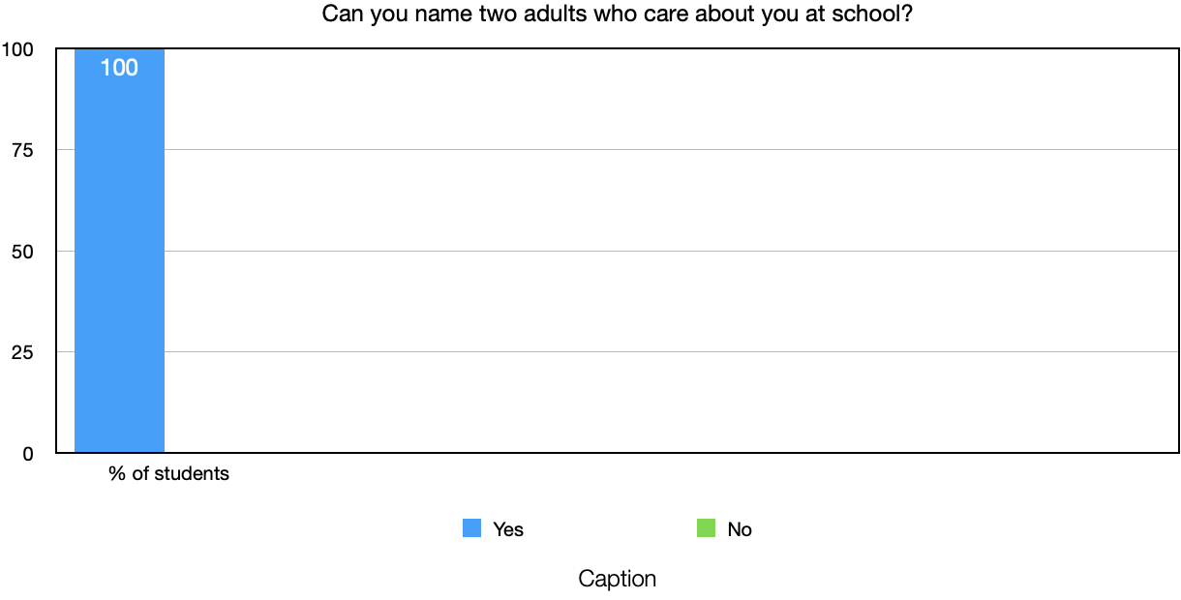

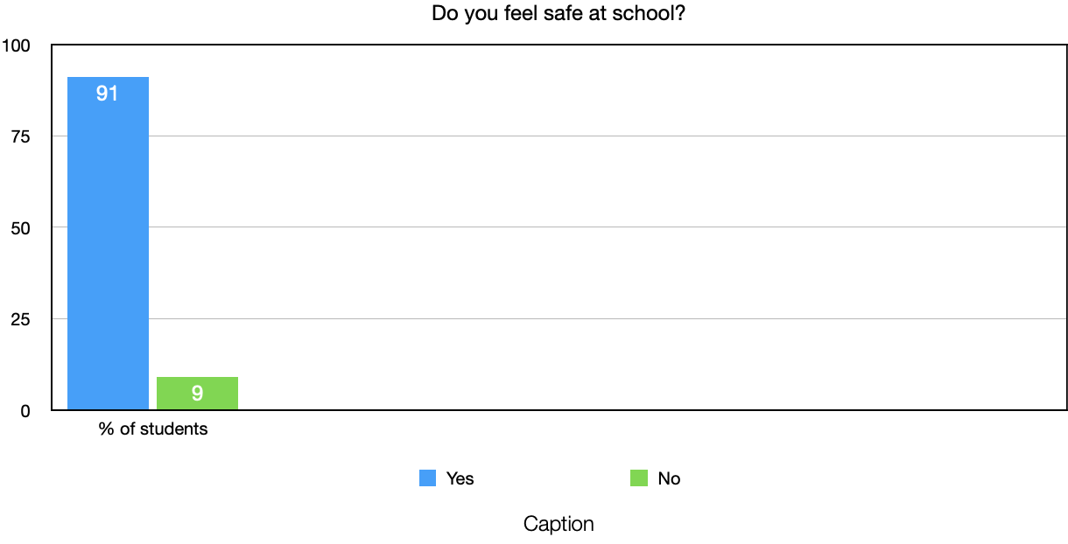

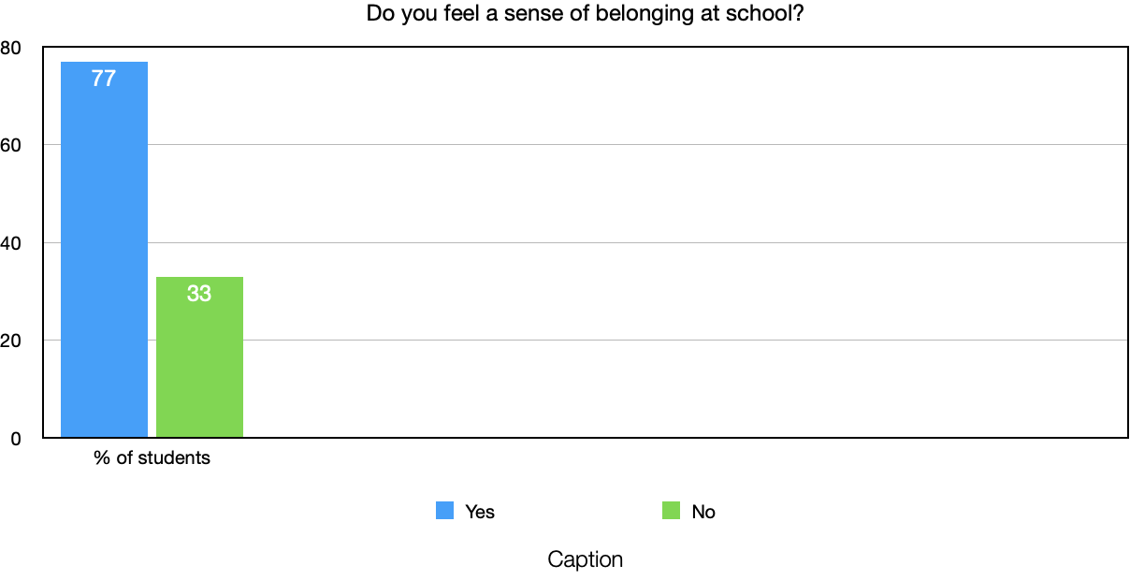
Goals

As a school community, we were proud of these results but also gained a greater understanding of the work that needs to continue. Our goal for this area is that every student will gain a sense of belonging at BESS, by deeply engaging in their learning and seeing themselves represented in our community.

Actions

This goal is being supported by several key actions.
- First, we open every day with our ‘Morning Circle’, where school updates are shared, each student checks-in, we learn a new Nedut’en word, and we play a game or do a dance. This routine has helped provide a ‘slow-start’ for students to begin the day. It has also helped develop positive connections between students and staff.
- To continue to develop a sense of belonging among students, we have initiated ‘Passion Project Fridays’ for our senior learners. This is a 2-hour block where they are free to explore their passions and to share them with the group.
- Senior students have begun to participate in ‘Student-Voice’ a district-wide program where students advocate for themselves.
- We host monthly Respect Assemblies to celebrate positive student choices.
- We have held several community/family lunches.
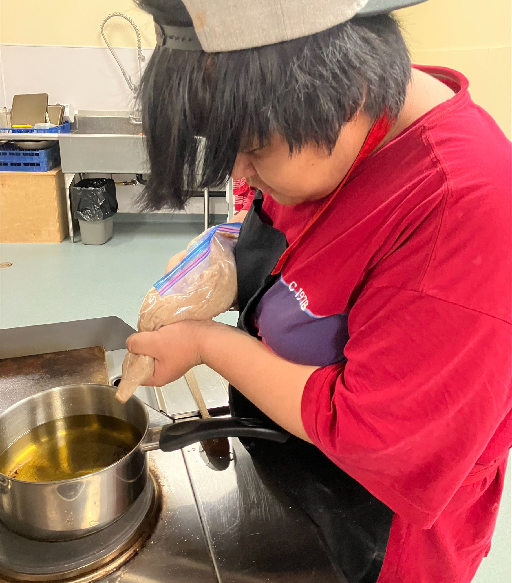
Students baking and exploring new recipes

June Update:
This term we have introduced the Zones of Regulation program to help students identify and discuss their feelings. This has been a wonderful addition to our morning circle and has helped the staff better support students at the start of the day. BESS has also been working hard to make culture a more visible piece of our school. Margie Alec has been leading daily drumming as a school. This is helping to have students build their sense of identity. This was demonstrated during our year end trip to Vancouver Island where the senior student shared culture at Zeballos Elementary Secondary School, as well as our year end Bah’lats.

November 2024 Update:
Our student survey this year demonstrated that once again every student could identify adults in the building who care about them or think they will be successful in life. The results also demonstrated that students continue to feel a sense of belonging at BESS. This year we added another question which provided essential information. We asked students “Can you explain what you are learning about and why it matters?”. The results showed that very few children could explain the importance of what we are learning at school. As a result, we are adjusting our goal.

Our updated goal is that every student will be more engaged in their learning and will be able to describe their learning and its importance. To address this we are beginning with a high interest area: culture. We have been in the planning stages to create a weekly culture night at BESS where community members, families, and students can come together to practice culture. Students will work with new activities like drumming, canning, beading, regalia creations, etc. They will also document what they have worked on by capturing pictures and creating ‘How To’ books to share their learning. We will also incorporate this process into the school days, where we are hoping to introduce more hands-on activities and have students reflect by creating texts or other stories to share out their learning.

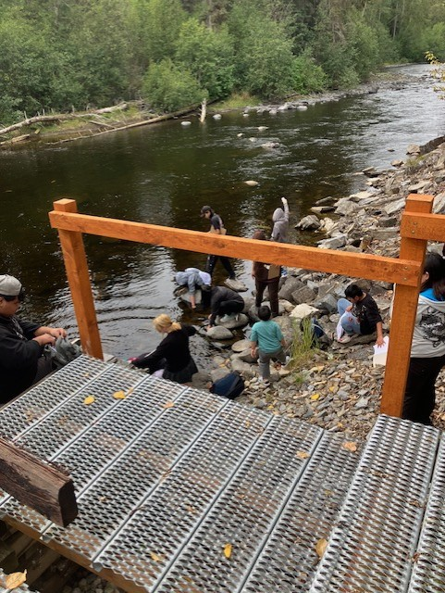

Highschool students studying water
quality at the river.

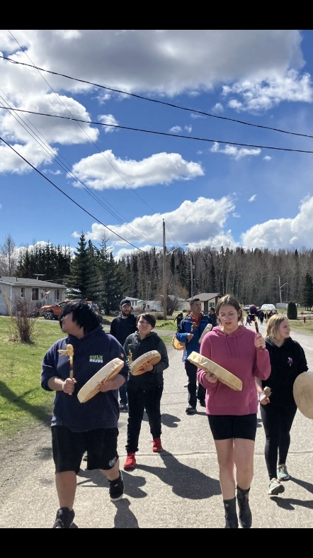
Our MMIWG walk

May 2025 Update:
Staff have been working diligently to improve student engagement. There has been an emphasis on hands-on learning opportunities. This term Miss Jeanette has worked with the senior and junior classes to build a mobile smoker and CO2 cars. We have also completed several of our ‘How To’ books after doing hands-on Indigenous learning. For example, the whole school came together to make B’eh salad and then again to write out our steps into a shareable book. Students have also been invested in our monthly Culture Nights and have helped with preparation and planning. Students have continued to enjoy our outdoor learning opportunities like our collaboration with Tyhee Forestry to learn about the forestry industry. Students have shined during these opportunities and have been much more engaged in their learning.

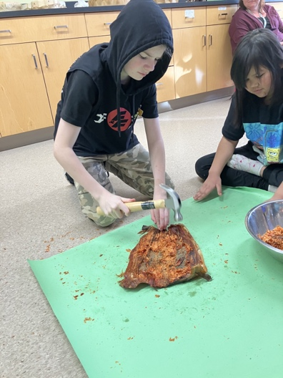

Making B’eh

Student Story:
When asked how he feels about Hands-On Learning at BESS student D said “I like hands-on learning because it’s more physical and it’s easier than writing with a pencil. We took apart the garden, we went to Winnipeg and learned about culture, we learned measurement and patience when we built a smoker. We should do all hands-on learning”.

November 2025 Update:

Now that we have some more staff at BESS, we have been able to roll out our sensory/regulation room. This is a space filled with sensory tools for students to use to regulate their emotions and to meet their sensory needs. Some students visit daily with an adult and go through a routine that emphasizes sensory movements. Others visit the room when they are upset and use the space to calm down. It has had a very positive impact on students and is helping BESS become a safer space for students.
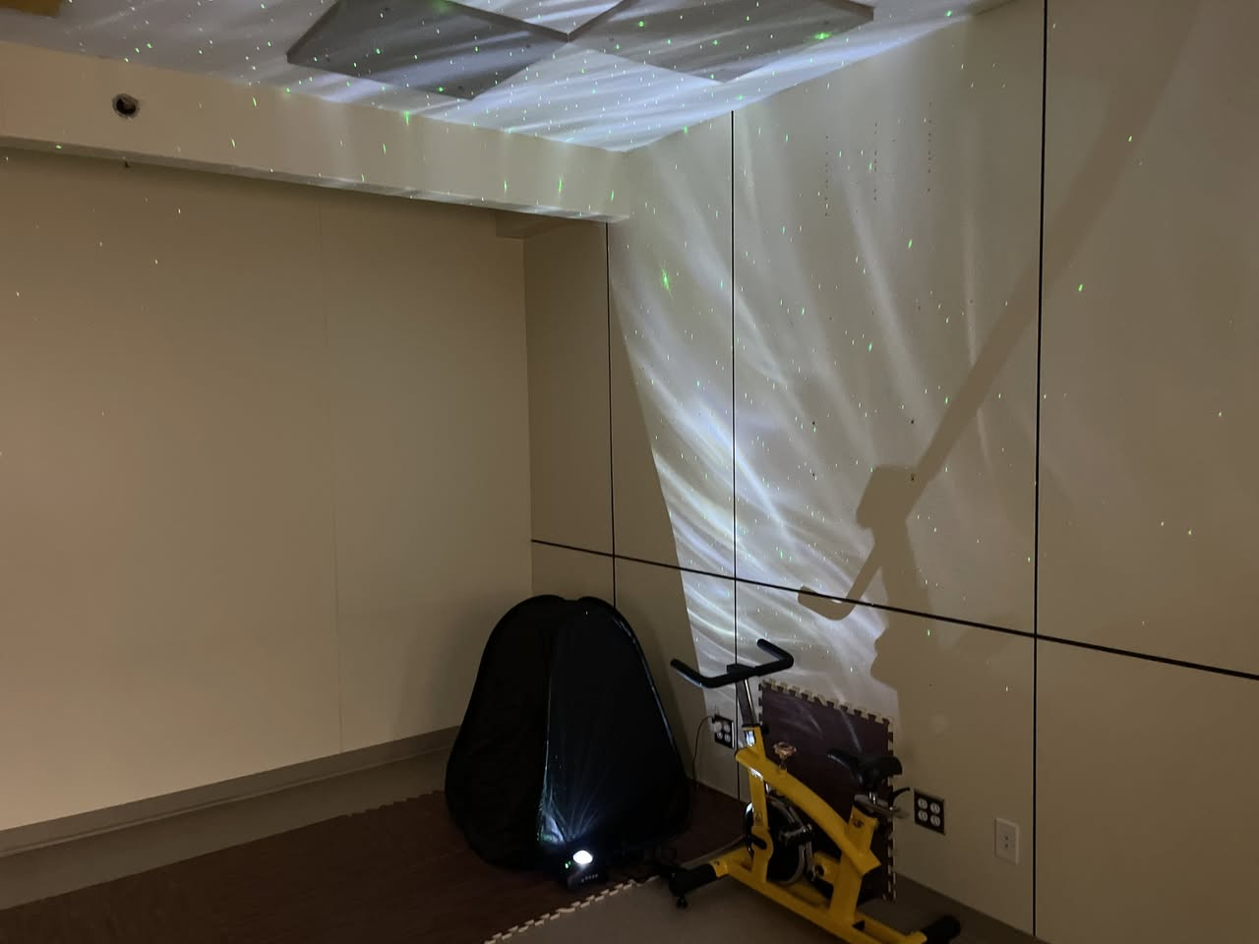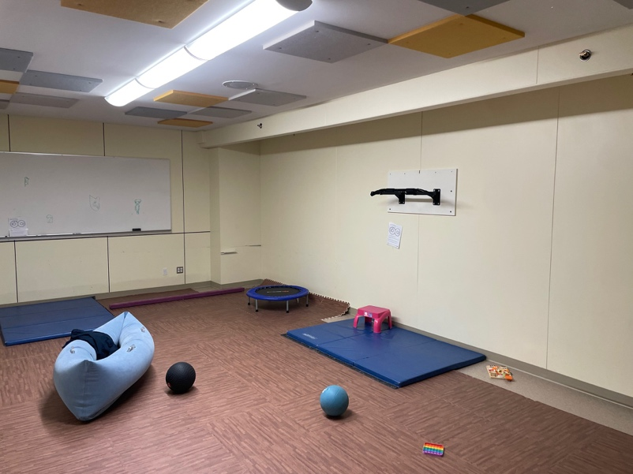

Sensory/regulation room

District Goal: Enhance Connections

As a remote community, it is paramount to have families and the broader community be active members of a school. At BESS one of our main goals is to maintain and build strong connections with our families and surrounding community members. We have worked towards this goal by following several practices. In prior years BESS has had an active PAC, who became passionate advisors and ran several programs and fundraisers. Unfortunately, as a result of the pandemic and being such a small community, the past few years it has been difficult to maintain a consistent PAC. This year we have made progress to reinstating our PAC. We have had monthly meetings and the PAC has begun to support initiatives such as our holiday family lunch. We have hosted several events open to the community and families, such as our opening day BBQ and our Truth and Reconciliation Day cultural celebration and lunch. These events have been well attended, and we strive to host more throughout the year.

BESS has also begun to work with the Village of Granisle and Lake Babine Nation on a sustainable food project, which will see community garden beds installed on our school field. Students have taken part in the consultation meetings and have enjoyed participating.

Lastly, students have begun to take an active role in the surrounding communities. We have arranged some volunteer opportunities for students, such as helping an elder in Tachet stack wood. Students have been active and enthusiastic participants in these opportunities.

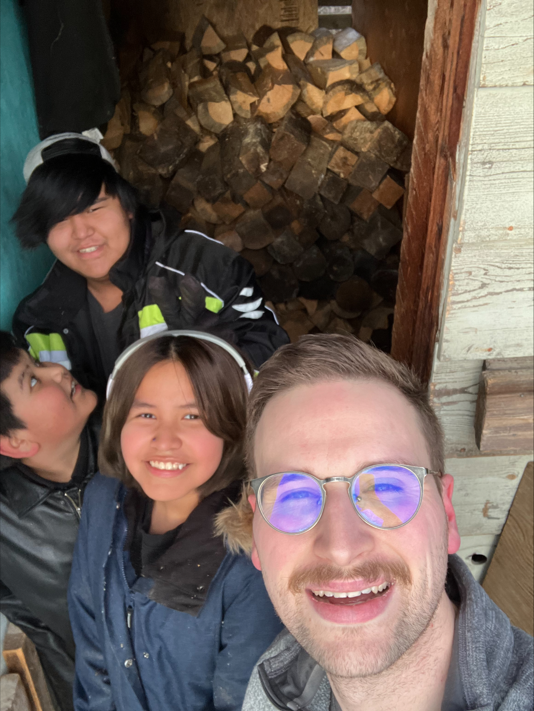
Stacking wood for an elder

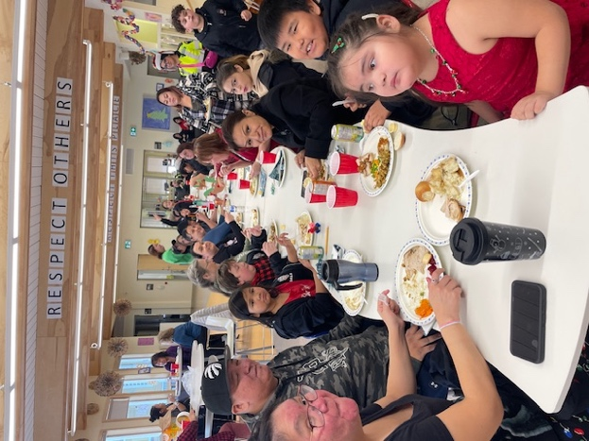

Students and families enjoying a holiday lunch

June 2024 Update:
We have continued to work towards enhancing connections here in Granisle. We have had some wonderful opportunities to learn from community members who have lead opportunities such as a forestry tour, carpentry projects, and CPR. On June 26th BESS cohosted a training Bah’lats with community members and elders. This was a spectacular event that was well-attended and provided an opportunity to learn from community members.

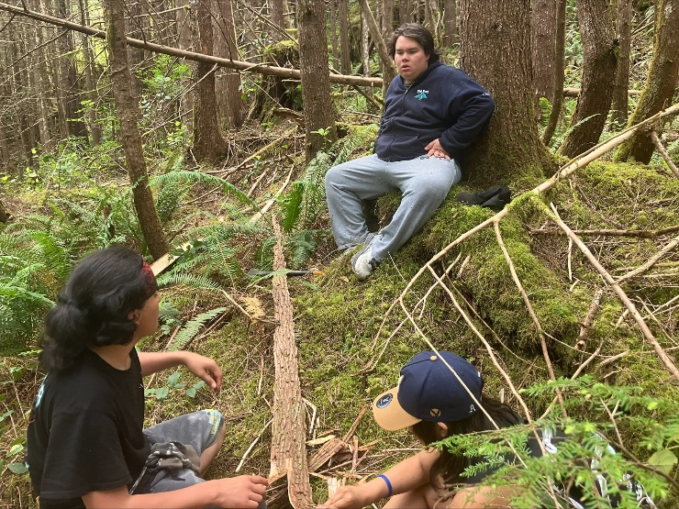
Students learning about coastal forest and
harvesting in Zeballos.

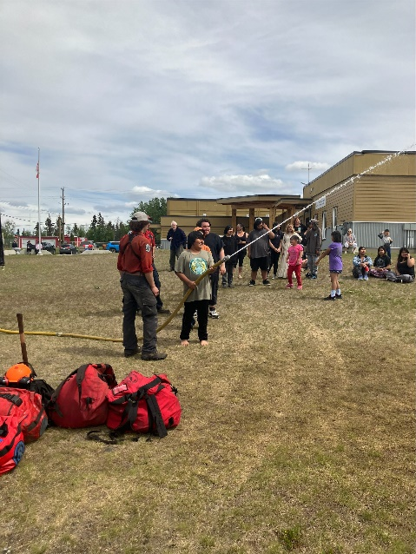
A visit from a local forestry company

November 2024 Update

Community involvement has once again been a focus for us this school year. This year the high school students hosted a lunch for local elders on Orange Shirt Day. The community and school came together to celebrate and acknowledge the elders. We are also consulting with several community members who will run our evening culture program. PAC has continued to be active throughout the year and has several projects planned for the rest of the year. We ended our first term at school with a well-attended holiday celebration. The junior class organized a class-wide sale, creating products and then selling them to other students, family members, and the public. This was a successful project that saw students develop financial and social skills. We then had a wonderful assembly which saw class presentations. The senior class ended their drama course by creating and presenting their own skits. The junior class and primary class also sang songs. After a visit from Santa to hand out gifts, we had an amazing lunch.

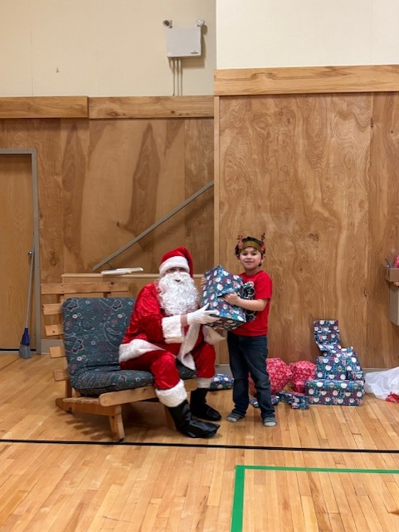
Santa visited the students

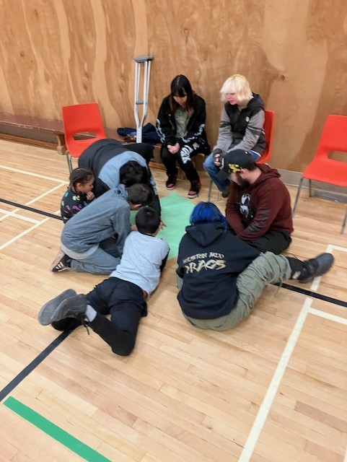
Multigrade collaboration during our morning meeting.

May 2025 Update:
This term the senior class had an incredible opportunity to travel to Winnipeg as part of an exchange through the YMCA. For many students this was their first time traveling outside of B.C. During the exchange they met new students and were exposed to other cultures and ways of being. This was an eye-opening experience for many. In June we will host the Winnipeg group here at BESS.

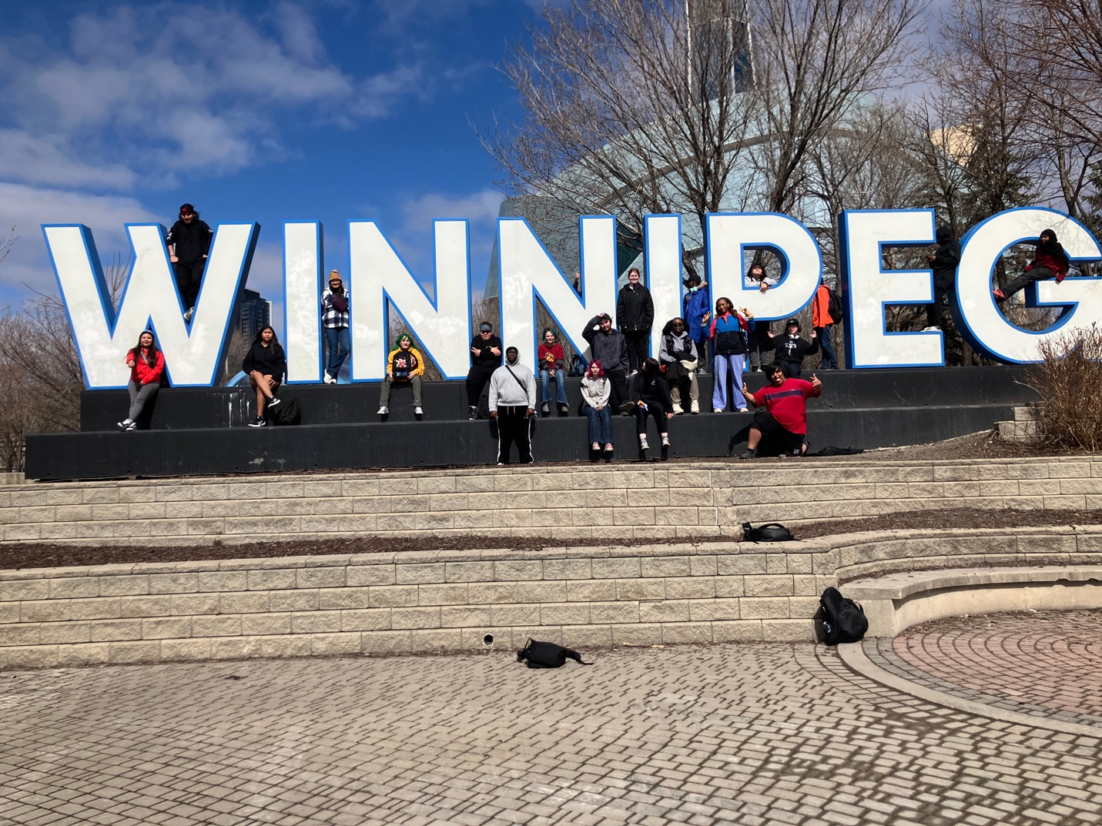

Senior students in Winnipeg

District Goal: Honour Diversity

One of the most spectacular aspects of BESS is its diversity and connection to culture. 76% of our student population has Aboriginal heritage, with 17 students who are members of Lake Babine Nation. As a school community, we understand that the more culture is visible and present, the stronger our school will be. Students participate in daily Language and Culture classes led by Margie Alec. In these classes, students are working on Nedut’en words and phrases, drumming, singing, and art. We are hoping to build fluency and make language more prevalent in our school. In order to accomplish this, we include a daily word in our morning circle and have hung up buttons with voice-recorded Nedut’en words and phrases around the school. Many staff members are also learning and using these same phrases around the school.

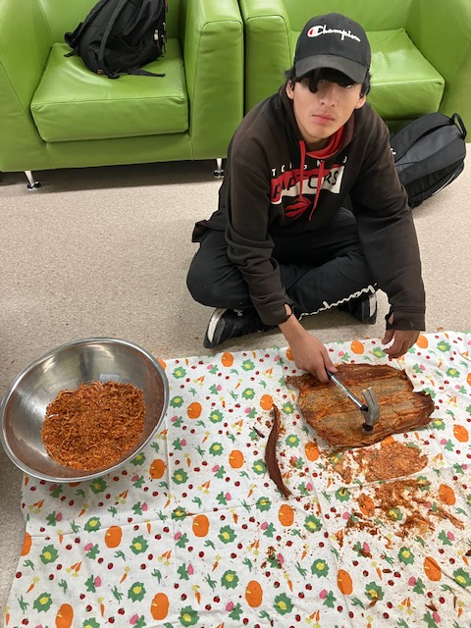
Making B’eh

June 2024 Update:

BESS has been diving into cultural practices this term. Margie Alec has been an incredible leader this term and has supported several major projects. Dorris Munger a local drummer and singer has written a new song for BESS called the ‘Happy Song’ using Nedut’en words the students have learned this year. The students are working at mastering this song. Senior students have also prepared gifts for the Bah’lats and for the June 16th trip to Zeballos BC where we were hosted and shared culture. Lastly, we have been out on the land celebrating our incredible lake. Students have been out on several canoe excursions with BESS over the past month. This gives students an opportunity to discuss and appreciate the rich history on Babine Lake.

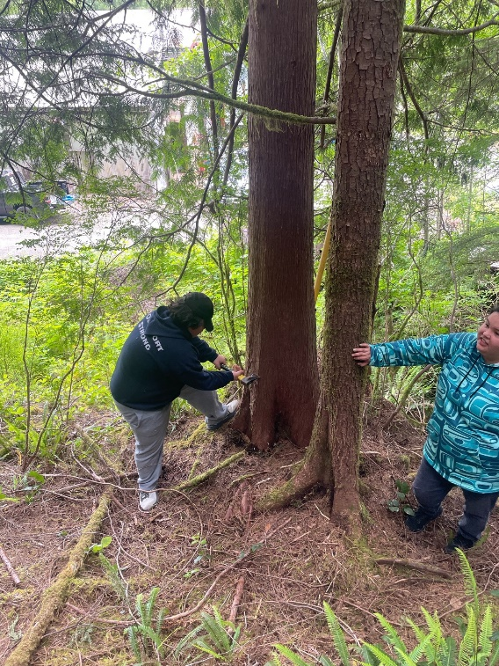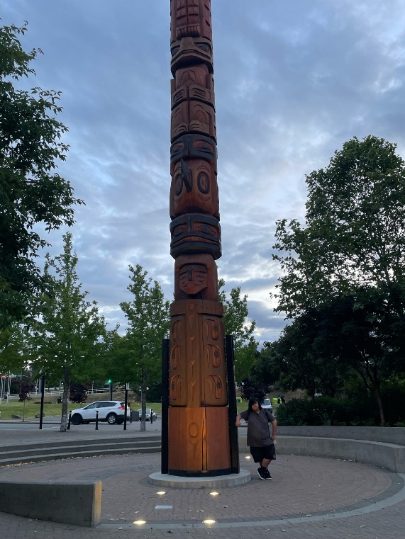
Photos from our trip to Zeballos and learning local knowledge.

November 2024 Update:

Celebrating our diversity and local culture continues to be a focus at BESS. This has included adding student led drumming to our daily morning routines. Students have also been invested in their daily Nedut’en classes. Our evening culture program will be another example of our investment into culture.

Student Story: Student C has become a leader during school culture activities. He steps up daily to lead morning drumming with Miss Margie and has even led it on days that she is away. This skill will benefit him throughout his life and is providing a cultural opportunity for other students in our school.
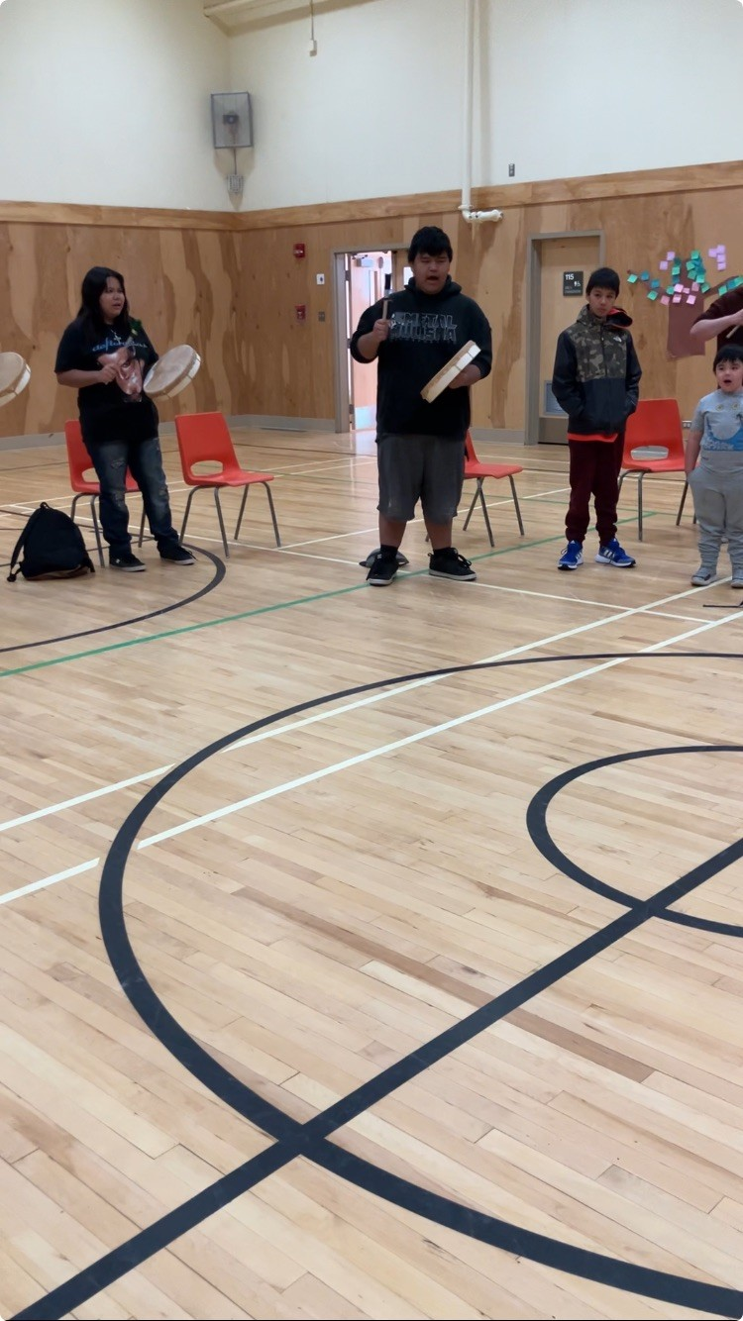
Student led drumming

May 2025 Update:

We started our monthly culture nights during this past term. We have worked with three knowledge keepers who organise lessons, language and drumming. These events have been well attended by community members and students have been thrilled to participate. Students have the opportunity to take a lead at the start of each culture night as they sing the Happy Song as our opening.

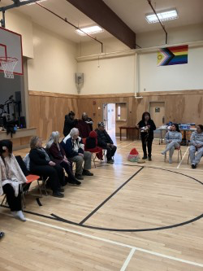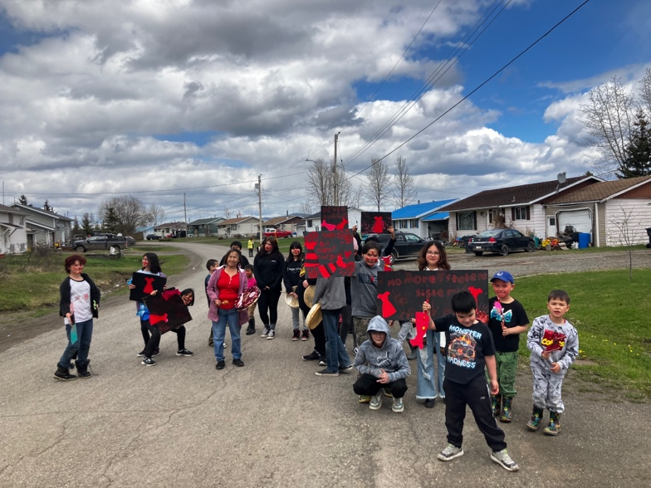
Culture Night at BESS MMIWG Walk to End Violence

District Goal: Activate Our Workforce

This year the staff has been active in professional development and growth opportunities, such as:
- Learning about local Indigenous practices and opportunities for reconciliation.
- Travelling to other schools to observe and learn from experienced educators.
- Learning about SOGI 123.
- Emphasizing experiential and hands-on learning.
- Several teachers and staff have begun to engage with MathUp.
- Staff members take an active role in the morning circle.
- Staff members support students’ passion projects.
- Many staff members have invested in Pro-D opportunities.
- Our language and culture team offers cultural teachings and brings in guests.

June 2024 Update:
This year saw concrete growth from our staff. Staff members grew their ability to initiate meaningful learning, as seen by several students’ jumps in reading and math. We also dedicated time to becoming more involved in local culture and events. This was apparent during the Bah’lats.

November 2024 Update:

Our staff has continued to grow and improve our teaching skills. Several staff members are involved in inquiry projects (NOIIE, Growing Innovation) to create hands-on learning projects for the students. These are provincially recognized programs that encourage teachers to collaborate and engage with new professional learning to better meet student needs. Last year our focus was on student engagement with hands-on learning. This year we are looking at specifically including hands-on local Indigenous activities to improve student engagement. We are also including new tools and resources in our daily practices. For example, several teachers have started to work with the Words Their Way phonics program. This has had a positive impact on improving reading with our elementary students. Our staff is made up of flexible and adjustable professionals.

May 2025 Update

This year staff has been very invested in their professional growth. Staff have attended literacy training, taken part of inquiry projects, and held independent professional development throughout the year. They have dedicated a considerable amount of time to hands-on learning opportunities for the students and have worked hard throughout the year to collaborate on these projects. Staff have also attended conferences like the May NOIIE conference in Vancouver. In June Jeanette Lapre will be presenting about hands-on learning at BESS at the Growing Innovations conference with other rural educators.

November 2025

Once again, the staff at BESS has been dedicated to consistent improvement and growth. As mentioned above in August and October 4 staff members including administrators, teachers and CUPE came together to work on building our literacy teaching skills at an event on the program ‘Structured Literacy’. It was powerful to have a full team participating in this program. We have also had some staffing changes at BESS. In the office we have added Crystal Cramm as our new office administrator, in the junior class Shin Hay has joined us as a new LSW, and Morgan Moore has returned to the kitchen.

